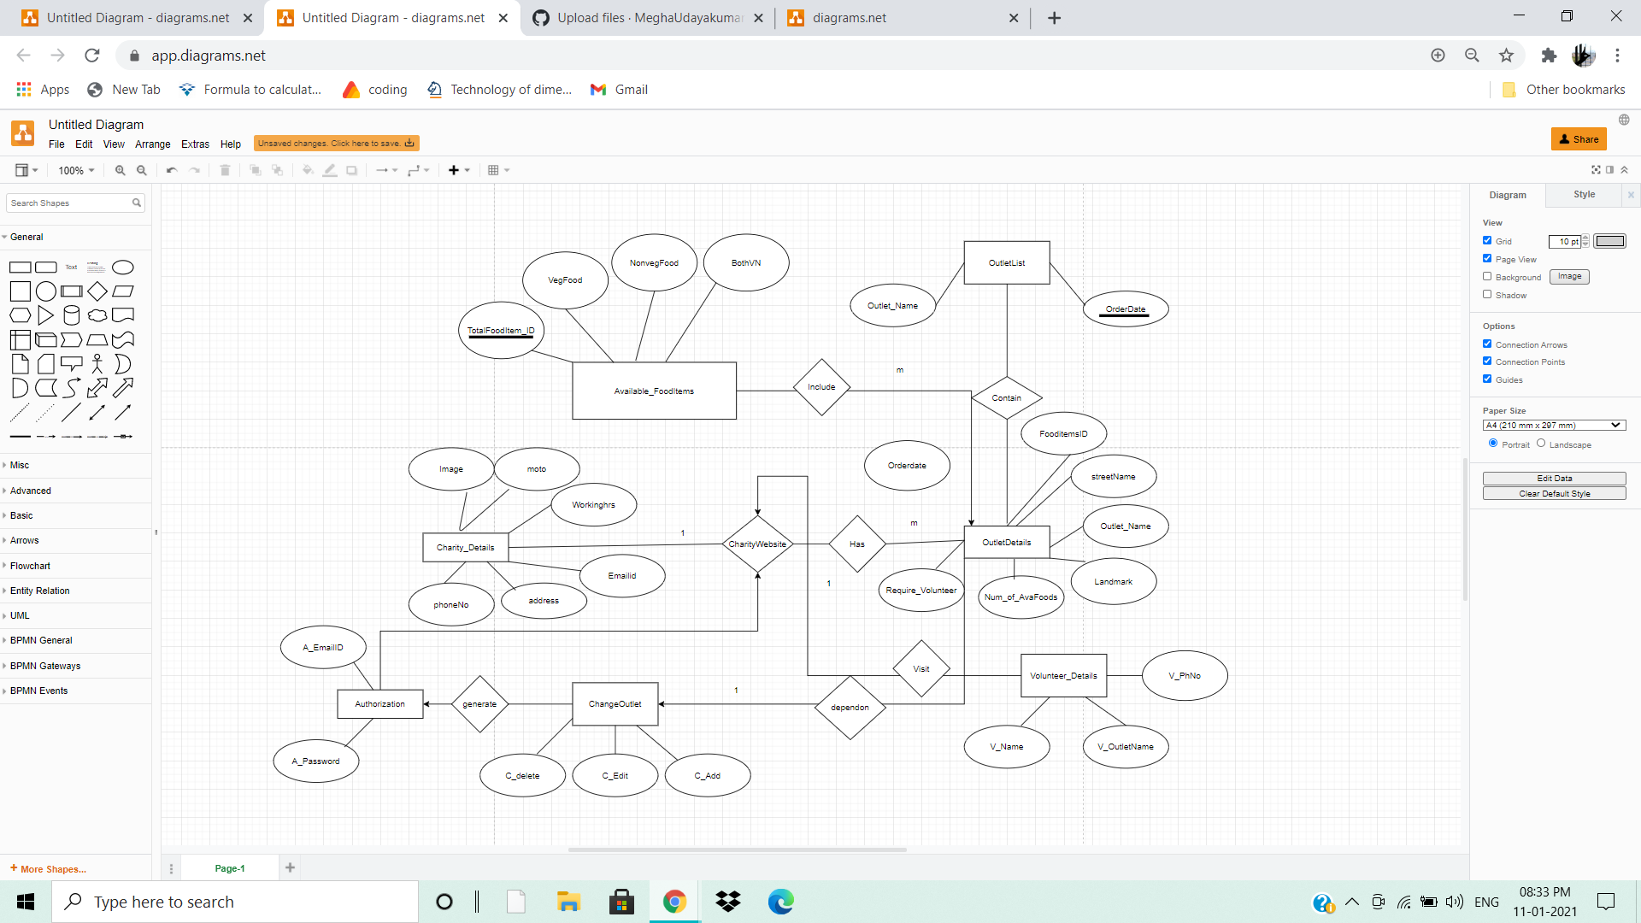

Queries:

CREATE TABLE Outlet_Details ( PRIMARY KEY(outlet_id),

(FOREIGN KEY FoodItem_ID ) REFERENCES Available_FoodItems(FoodItem_ID ),

(FOREIGN KEY outlet_Name ) REFERENCES List_Outlet(Outlet_Name) ,

StreetName VARCHAR(30) ,

Landmark VARCHAR(30) ,

No-of-AvaiFoods INT NOT NULL,

Require-Volunteer INT NOT NULL,

Availabledate DATETIME) ;

INSERT VALUES()….

Select * from Outlet_Details ORDER BY StreetName ASC;

CREATE TABLE Available_FoodItems ( PRIMARY KEY FoodItem_ID ,

VEG INT NOT NULL,

NV INT NOT NULL,

Total_Food_items INT NOT NULL,

FOREIGN KEY(Outlet_Name) REFERENCES Outlet_Details(outlet_Name);

INSERT VALUES()….

Select* from Available_FoodItems ;

CREATE TABLE List_Outlet( UNIQUE Outlet_Name VARCHAR(20), OrderDate DATETIME );

INSERT VALUES()….

Select * from List_Outlet ORDER BY OrderDate ASC;

CREATE TABLE Volunteer_Details( PRIMARY KEY V_ID, V_Name Char(20), V_PhNo INT NOT NULL, V_Select_Outlet Char(30) NOT NULL);

INSERT VALUES()….

Select * from Volunteer_Details ;